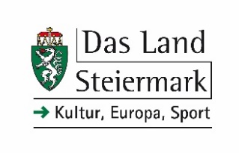

STYRIA-ARTIST-IN-RESIDENCE-Scholarship (St.A.i.R.) 2025

To
Amt der Steiermärkischen Landesregierung
Abteilung 9 Kultur, Europa, Sport
Landhausgasse 7
A 8010 Graz

Application Form
Time limit of submission: August 15, 2024 (beteil-kultint@stmk.gv.at)

First name Surname

Address (Zip code/Place/Street etc.)

Phone E-Mail

Website

Date of birth Place of birth Nationality

Duration of stay/preferred period Artistic field

Brief description of artistic plans (obligatory max. 1000 char.)

The application documents should by using the attached form contain a motivation letter, short curriculum vitae, information about the desired duration of the stay (minimum two months), a description of the artistic/art-theoretical work project (max. 1000 keystrokes), examples of previous work in the form of a portfolio; max. 5 representative links can be provided as further information. All together not more than 20 pages max. 10 MB.

There is no individual legal claim to be allocated a scholarship position.

Should there be restrictions due to unforeseeable occurrences, Land Steiermark will not assume any liability if scholarships cannot be started. Likewise, there is no entitlement to substitute compensatory payments for scholarship holders.

Data protection provisions:

Your participation in the call for proposals confirms the acceptance of the following conditions:
The applications submitted are treated by the office the Regional Government of Styria / Department 9 Culture, Europe, Sports.
Your personal data will solely be processed in the course of the evaluation of the call for proposals through our jury, the award ceremony, as well as for the necessary documentation of your data.
We would furthermore like to draw your attention to the fact that the awardee will be publicly announced. In the course of the award ceremony, picture and sound recordings of the awardee will be established and made public. Publication is planned in printed media, social media and on the websites of Land Steiermark; Land Steiermark, acting as the awarding institution, has a legitimate interest in the documentation and publication of the event.
The data-protection-website of Land Steiermark provides further information: https://datenschutz.stmk.gv.at

Place/Date Signature

